HOMEWORK 2
Part 1:
Для данной работы выбран сценарий: Управление ветеринарной клиникой. Эта система будет управлять владельцами питомцев, самими питомцами, врачами-ветеринарами, приемами и историями болезней.
Part 2:
Идентификация Сущностей и Атрибутов:
1. Владельцы питомцев (Owners)
2. Питомцы (Pets)
3. Врачи-ветеринары (Doctors)
4. Приемы (Appointments)
5. Истории болезни (Histories of appointments)

Проектирование Таблиц:
1. Table Name: Owners
Description: Contains information about pet owners.
Attributes:
OwnerID: INTEGER, PK
FullName: VARCHAR(100), NOT NULL
Email: VARCHAR(100), NOT NULL, UNIQUE
Constraints:
PK_Owners: PRIMARY KEY (OwnerID)
UQ_Email: UNIQUE (Email)

2. Table Name: Pets
Description: Contains information about pets.
Attributes:
PetID: INTEGER, PK
InsuranceNum: VARCHAR(50), NOT NULL, UNIQUE
Age: FLOAT, NOT NULL
OwnerID: INTEGER, FK (REFERENCES Owners), NOT NULL
Constraints:
PK_Pets: PRIMARY KEY (PetID)
UQ_InsuranceNum: UNIQUE (InsuranceNum)
CHK_Age: CHECK (Age > 0)
FK_Pets_Owners: FOREIGN KEY (OwnerID) REFERENCES Owners (OwnerID)

3. Table Name: Doctors
Description: Contains information about vet doctors.
Attributes:
DoctorID: INTEGER, PK
FullName: VARCHAR(100), NOT NULL
LicenseNum: VARCHAR(50), NOT NULL, UNIQUE
Constraints:
PK_Doctors: PRIMARY KEY (DoctorID)
UQ_LicenseNum: UNIQUE (LicenseNum)

4. Table Name: Appointments
Description: Contains information about appointments, implements a many-to-many relationship between pets and doctors.
Attributes:
AppointmentID: INTEGER, PK
PetID: INTEGER, FK (REFERENCES Pets), NOT NULL
DoctorID: INTEGER, FK (REFERENCES Doctors), NOT NULL
AppointmentDate: TIMESTAMP, NOT NULL
AppointmentStatus: VARCHAR(20)
Constraints:
PK_Appointments: PRIMARY KEY (AppointmentID)
CHK_AppointmentDate: CHECK (AppointmentDate >= ‘2010-01-01’ AND AppointmentDate <= ‘2027-01-01’)
FK_Appointments_Pets: FOREIGN KEY (PetID) REFERENCES Pets (PetID)
FK_Appointments_Doctors: FOREIGN KEY (DoctorID) REFERENCES Doctors (DoctorID)
CHK_ApppointmentStatus: CHECK (AppointmentStatus IN (‘SCHEDULED’, ‘CANCELED’, ‘FINISHED’))

5. Table Name: MedicalHistory
Description: Contains information about history of appointments.
Attributes:
HistoryID: INTEGER, PK
PetID: INTEGER, FK (REFERENCES Pets), NOT NULL
DoctorID: INTEGER, FK (REFERENCES Doctors), NOT NULL
HistoryStatus: VARCHAR(20)
Treatment: VARCHAR (100), NOT NULL
Comments: VARCHAR (200), NOT NULL
Constraints:
PK_MedicalHistory: PRIMARY KEY (HistoryID)
FK_ MedicalHistory_Pets: FOREIGN KEY (PetID) REFERENCES Pets (PetID)
FK_ MedicalHistory_Doctors: FOREIGN KEY (DoctorID) REFERENCES Doctors (DoctorID)
CHK_HistoryStatus: CHECK (HistoryStatus IN (“HEALTHY”, “NEED ADDITIONAL TREATMENT”))

Взаимосвязи:
Owners and Pets (One-to-Many): One person can own many pets, but one pet basically has one main owner.
Pets.OwnerID is a foreign key, referenced to Owners.OwnerID.
Pets and Doctors (Many-to-Many via Appointments): A pet can visit multiple doctors over time, and a doctor can treat multiple pets. This relationship is resolved through the Appointments table.
Appointments.DoctorID is a foreign key, referenced to Doctors.DoctorID;
Appointments.PetID is a foreign key, referenced to Pets.PetID.
Pets and MedicalHistory (One-to-one): One pet can have only one medical history and medical history may belong to only one pet.
MedicalHistory.PetID is a foreign key referenced to Pets.PetID.
Doctors and MedicalHistory (One-to-many): One doctor can manage many medical histories, but one medical history is conducted by only one doctor.
MedicalHistory.DoctorID is a foreign key referenced to Doctors.DoctorID.

Part 3:
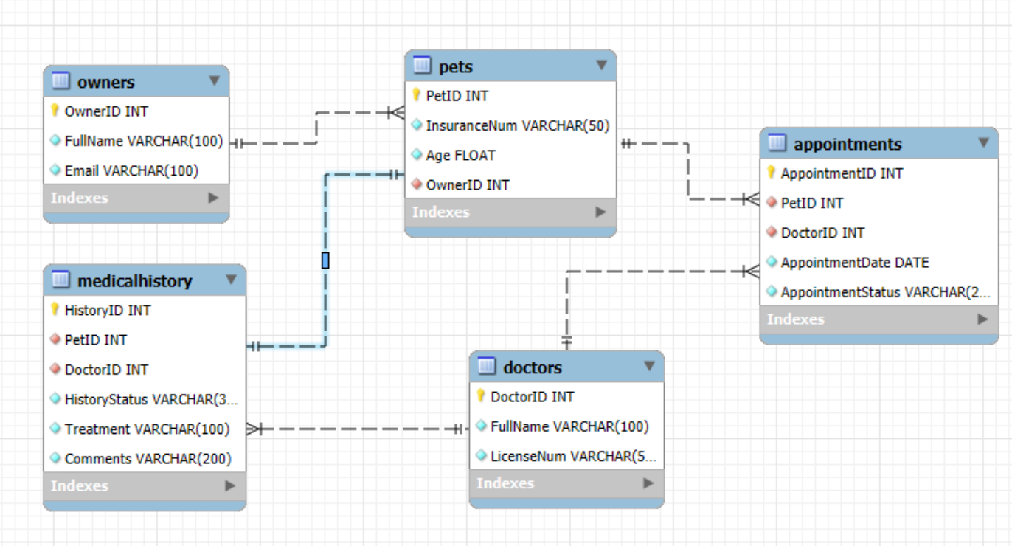
Рисунок 1--ER-диаграмма
The database built according to the diagrams can be used in vet clinics to optimize data management and store information more securely.

